**PolicyPal**

**Insurance Information Self-Service Query Program**



**642115503 Haoxuan Yu**

**642115502 Guangcheng Zhou**

**642115008 Jirapat Namwong**

**642115508 Yingyi Mao**

**642115509 Zhenyu Pan**

**BACHELOR OF SCIENCE**

**SOFTWARE ENGINEERING PROGRAM**

**COLLEGE OF ARTS, MEDIA AND**

**TECHNOLOGY**

**CHIANG MAI UNIVERSITY**

**TABLE OF CONTENTS**

CHAPTER 1 | Introduction and Background 2

CHAPTER 2 | Project Plan 3

2.1 Goals and Objectives 3

2.2 Deliverables and Limits 4

2.3 Benefits 5

2.4 Target user 6

2.5 Three personas 7

CHAPTER 3 | Literature Review 9

CHAPTER 4 | SWOT analysis 12

CHAPTER 5 | Type of user 13

CHAPTER 6 | Features 14

CHAPTER 7 | Timeline 15

CHAPTER 8 | Cost estimation 16

CHAPTER 9 | Risk and Solution 17

CHAPTER 10 | User journey 20

CHAPTER 11 | URS and SRS 21

CHAPTER 12 | Use case diagram 22

CHAPTER 13 | Use case description 25

CHAPTER 14 | Activity Diagram 32

CHAPTER 15 | Non-functional requirement with fit criterias 33

CHAPTER 16 | UI 34

CHAPTER 17 | Traceability Table/Matrix 35

# **CHAPTER 1 | Introduction and Background**

In the world of insurance, policyholders frequently struggle with an array of issues stemming from their insurance policies. Some of these concerns are immediate, while others represent long standing queries and needs that persist over time. Regrettably, the process of addressing these issues typically involves protracted and often exhausting interactions with customer service representatives or manual agents.

This situation invariably leads to a sense of frustration among users who find themselves mired in an unpredictable web of extended waiting periods, confused insurance terminology, and many more. The toll of this predicament extends not only to the policyholders themselves but also to the substantial strain it places on customer service resources. These resources must navigate the landscape of customer inquiries, resulting in inefficiencies and suboptimal experiences for all parties involved.

In recognition of the pressing need to address these pervasive challenges and to elevate the overall user experience within the insurance domain, we take immense pride in introducing the "Insurance Information Self-Service Query Program." or we call it “PolicyPal” This groundbreaking initiative has been meticulously crafted to empower policyholders with an innovative and user-centric solution that will redefine their interactions with insurance policies.

Our program seeks to not only alleviate the pain points that policyholders regularly encounter but also to streamline and optimize the operational efficiency of insurance providers. Through a user-friendly, self-service platform, we aim to grant individuals direct access to the vital information they require, all at their fingertips. This means an end to the long wait times, a simplified understanding of complex insurance terminology, and a significant reduction in the consumption of valuable customer service resources.

The "Insurance Information Self-Service Query Program" is not merely a solution; it represents a transformative step toward a more transparent, efficient, and user-centric insurance industry. We extend a warm invitation for you to try this journey as we revolutionize how policyholders engage with their insurance policies, offering clarity, convenience, and peace of mind like never before.

# CHAPTER 2 | Project Plan

## **2.1 Goals and Objectives**

The primary goal of this project is to develop a user-friendly mobile application that simplifies the management and understanding of insurance policies for a diverse user base. This application aims to empower users with the tools and knowledge needed to make informed insurance decisions and streamline the insurance management process. Additionally, it seeks to enhance accessibility for all individuals interested in or involved with insurance.

Our objective is to develop a user-friendly mobile application that simplifies insurance for a broad audience and equips users with the knowledge and tools to make informed insurance decisions. We aim to streamline insurance management by enabling users to effortlessly access clear summaries of their insurance policies with just their name, surname, and ID number. Furthermore, our application will facilitate convenient appointment booking with local insurance offices for policy renewal, ensuring that users can easily engage with their insurance providers when needed.

We aspire to foster insurance literacy among all users, providing comprehensive educational resources and recommendations tailored to their individual needs. We are committed to ensuring the accessibility of our platform to users of diverse backgrounds, including those with disabilities. Our continuous efforts will center around user engagement, data security, scalability, and performance optimization to deliver a seamless and valuable insurance management tool to our users.

## **2.2 Deliverables and Limits**

**Client**:

* User Registration: Allow users to create accounts with their personal information securely.
* User Login: Implement a secure login mechanism to grant access to registered users.
* Insurance Policy Summarization: Develop a feature that enables users to input their name, surname, and ID number to obtain clear and concise summaries of their insurance policies.

**System:**

* User Management: Develop the system's capability to add and manage user accounts securely.
* User Verification: Implement mechanisms for verifying user identity and ensuring data security.
* Insurance Policy Database: Retrieve and maintain an up-to-date database of insurance policies to provide accurate summaries.
* Appointment Booking Management: Create a system that allows users to schedule appointments with local insurance offices for policy renewal.

**Documentation and Other Materials:**

* Proposal: Prepare a comprehensive project proposal outlining the application's objectives, scope, and expected outcomes.
* Project Plan: Develop a detailed plan specifying project milestones, timelines, and resource allocation.
* Software Requirement Specification: Document the functional and non-functional requirements of the application to guide the development process.

**Limits:**

* Internet Connection Requirement: The application relies on an internet connection for its functionality and data retrieval.
* Mandatory User Login: Users must log in to access and use all functions within the application, ensuring data security.
* User Agreement Acceptance: Prior to usage, users are required to accept the terms and conditions outlined in a user agreement.
* Limited Platform Support: The application is compatible with iOS and Android systems, catering to users on these platforms.
* Geographic Restriction: The application is available exclusively in Thailand, limiting its accessibility to users within this geographical area.

## 2.3 Benefits

1. **Simplified Insurance Management**: Users can effortlessly access clear and concise summaries of their insurance policies by entering basic personal information. This simplification of policy understanding saves time and reduces confusion.
2. **Easy Appointment Booking**: Users can conveniently schedule appointments with local insurance offices through the app, facilitating face-to-face interactions for policy renewal and inquiries.
3. **Accessibility and Inclusivity**: The application is designed to be accessible to users with diverse backgrounds, including those with disabilities, ensuring inclusivity for a wide range of users.
4. **Improved User Experience**: By offering a user-friendly interface and comprehensive features, the application enhances the overall user experience, making it easier and more enjoyable for users to manage their insurance needs.
5. **Geographic Relevance**: The application's availability exclusively in Thailand caters to the local insurance market, providing users with region-specific information and services.
6. **Time and Resource Efficiency**: Users can save time by quickly accessing policy information, submitting claims, and booking appointments through a single, user-friendly platform. This efficiency benefits both users and insurance providers.
7. **Transparent and Informed Users**: Through educational content and policy summaries, users become more aware of their insurance coverage and responsibilities, leading to a more transparent relationship between insurers and policyholders.

## 2.4 Target user

* **Individual Policyholders**: This group comprises individuals who have one or more insurance policies, such as health, auto, home, or life insurance. They seek a convenient solution to access, understand, and manage their insurance policies efficiently.
* **Local Insurance Office Visitors**: Users who prefer in-person interactions with insurance providers can use the application to book appointments with local insurance offices for policy renewals, inquiries, or consultations.
* **Users with Diverse Backgrounds**: The application is designed to be inclusive and accessible to individuals with diverse backgrounds and varying levels of technical proficiency, ensuring that it can cater to a wide audience.
* **Residents of Thailand**: The application's availability exclusively in Thailand caters to the specific insurance needs and regulations of the local market, making it highly relevant for residents in the region.
* **Users Seeking Convenience**: Users who value convenience and time savings in managing their insurance-related tasks.
* **Tech-Savvy Users**: Individuals who are comfortable using mobile applications and technology to streamline their insurance-related activities will find the application to be a valuable tool.

## 2.5 Three personas

|  |
| --- |
| 1. Sarah |
| **Demographics**  Sarah is a 35-year-old marketing executive with a hectic work schedule. She juggles multiple responsibilities, including managing her health, auto, and home insurance policies. |
| **Needs and wants**  Sarah seeks a convenient solution to access and understand her insurance policies quickly. She values time efficiency and appreciates the ability to book appointments with local insurance offices during her limited free time.  Her busy schedule makes it challenging to keep track of policy details and visit insurance offices for renewals. She may also find insurance terminology confusing. |

|  |
| --- |
| 1. John |
| **Demographics**  Raj, a 28-year-old tech enthusiast, is new to the world of insurance. He's recently purchased auto and renters insurance and wants to understand them better. |
| **Needs and wants**  Raj seeks educational resources to grasp insurance concepts and principles. He prefers digital solutions and values the convenience of managing his policies and understanding insurance terminologies through an app. |

|  |
| --- |
| 1. Maria |
| **Demographic**  Maria, a 65-year-old retiree, values in-person interactions with her insurance provider. She has health, life, and home insurance policies, which she wants to renew and discuss in detail. |
| **Needs and wants**  Maria prefers booking appointments at local insurance offices for policy renewals and face-to-face consultations. She wants a simple way to manage her policies while maintaining a personal touch. Also, she finds it challenging to access information online and prefers the comfort of in-person meetings with insurance agents. |

# CHAPTER 3 | Literature Review

**Business and Software Review**

1. **PolicyBazaar**

PolicyBazaar is a popular insurance comparison platform based in India. It allows users to compare and purchase a wide range of insurance policies, including health, life, auto, and more. While its primary focus is on insurance comparison, it may offer features related to policy management and claims submission.

**The Pros:**

* Wide Insurance Coverage: PolicyBazaar offers a vast selection of insurance policies from various providers, giving users the ability to compare and choose the most suitable coverage.
* Convenient Comparison: Users can easily compare policies side by side, helping them make informed decisions about their insurance needs.
* Online Purchases: It allows users to purchase insurance policies directly through the platform, streamlining the buying process.

**The Cons:**

* Limited Policy Management: While it may offer policy management features, its primary function is comparison, so policy management tools may be less robust.
* Region-Specific: PolicyBazaar primarily serves the Indian market, which may limit its usefulness for users in other regions.
* Limited Claims Support: The extent of claims support and digital claims submission may vary depending on the insurance providers partnered with the platform.

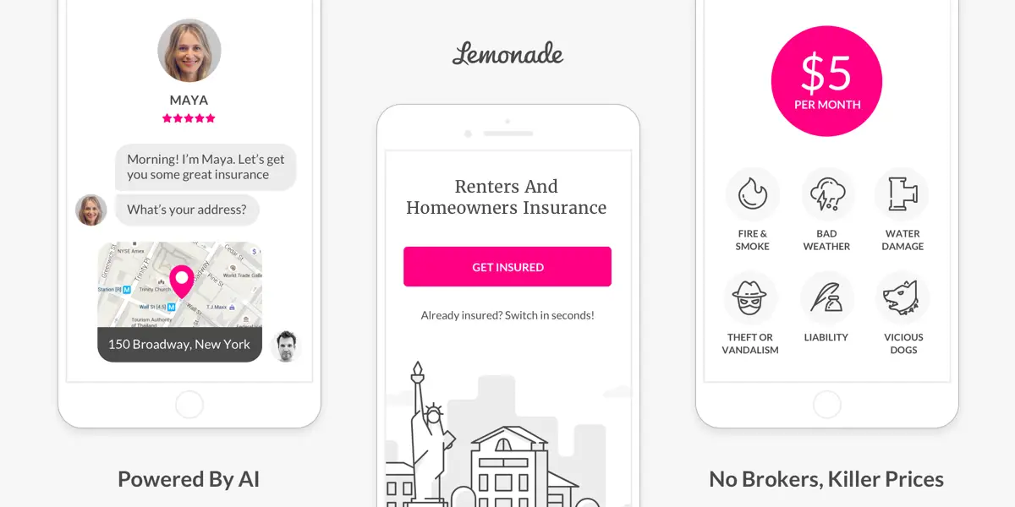

1. **Lemonade**

Lemonade is a prominent InsurTech company that offers renters, homeowners, and pet insurance. The Lemonade mobile app provides policyholders with a user-friendly platform for managing their policies and filing claims digitally.

**The Pros:**

* Digital Policy Management: Users can easily access and manage their insurance policies within the app, including reviewing coverage details and making changes.
* Quick Claims Processing: Lemonade's digital platform streamlines the claims submission and processing, often providing fast responses to claims.
* Transparency: The app is known for its transparency in pricing and claims processing, which can build trust with users.

**The Cons:**

* Limited Insurance Types: Lemonade focuses on specific insurance types (renters, homeowners, pets), which may not cover the full spectrum of users' insurance needs.
* Availability: Lemonade's services may be limited to certain regions and may not be available everywhere.
* No Face-to-Face Interaction: While the app provides a seamless digital experience, it lacks the option for users to meet with insurance agents in person.

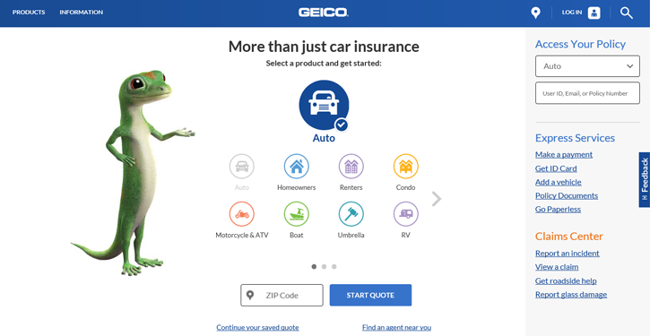

1. **GEICO**

GEICO Mobile is the mobile app for GEICO, a major auto insurance provider in the United States. The app is tailored for auto insurance customers and offers various features for policy management and claims handling.

**The Pros:**

* Auto Insurance Management: GEICO policyholders can use the app to access their auto insurance policy information, view ID cards, and make policy changes.
* Claims Handling: Users can file and track auto insurance claims through the app, offering convenience during stressful situations.
* Roadside Assistance: The app provides access to GEICO's roadside assistance service, making it helpful for drivers in need of assistance.

**The Cons:**

* Limited Insurance Types: GEICO Mobile focuses exclusively on auto insurance, so users with other insurance needs may require additional apps or services.
* Regional: GEICO primarily serves customers in the United States, limiting its availability to a specific geographical area.
* Auto-Centric: The app's features are centered around auto insurance, which may not cater to users with broader insurance portfolios.

# CHAPTER 4 | SWOT analysis

| **Strength**   * Efficient Policy Summarization: The application's ability to quickly summarize all of a user's insurance policies using their name, surname, and ID number is a significant strength. * Streamlined Appointment Booking: The feature that allows users to book appointments with local insurance offices for policy renewal. * Enhanced User Experience: By providing a user-friendly interface and simplifying complex insurance processes, the application aims to enhance the overall user experience, making it more accessible to a wider audience. * Data Security Measures: The implementation of robust data security and privacy measures ensures that user information is protected, building trust among users concerned about their privacy. | **Weakness**   * Dependency on User Data: The application heavily relies on users providing accurate name, surname, and ID number information. Any inaccuracies or incomplete data may affect the accuracy of policy summarization. * Internet Connection Requirement: The app's dependency on an internet connection for functionality may limit its usability in areas with poor connectivity. * Competition: The insurance industry has various established players and technologies. Gaining a competitive edge and attracting users from existing platforms may be a challenge. |
| --- | --- |
| **Opportunity**   * Insurance Literacy Promotion: expand the app's educational resources to further promote insurance literacy among users, making it a valuable resource for those seeking to understand their policies better. * Global Expansion: While initially available in Thailand, there is potential for global expansion to serve users in different countries with varying insurance needs. * Additional Insurance Services: The app can explore partnerships with insurance providers to offer additional services, such as insurance quotes, policy comparison, or investment-related features. | **Threats**   * Data Privacy Regulations: Evolving data privacy regulations and compliance requirements may pose challenges in managing user data securely. * Technical Challenges: Technical issues, such as system downtime, bugs, or security breaches, could harm the app's reputation and user trust. * User Adoption: Convincing users to trust a new platform with their insurance information and adopt it as their primary tool for insurance management may require effective marketing and user education efforts. |

# CHAPTER 5 | Type of user

* **Individual Policyholders**: This group comprises individuals who have one or more insurance policies, such as health, auto, home, or life insurance. They seek a convenient solution to access, understand, and manage their insurance policies efficiently.
* **Local Insurance Office Visitors**: Users who prefer in-person interactions with insurance providers can use the application to book appointments with local insurance offices for policy renewals, inquiries, or consultations.
* **Users with Diverse Backgrounds**: The application is designed to be inclusive and accessible to individuals with diverse backgrounds and varying levels of technical proficiency, ensuring that it can cater to a wide audience.
* **Residents of Thailand**: The application's availability exclusively in Thailand caters to the specific insurance needs and regulations of the local market, making it highly relevant for residents in the region.
* **Users Seeking Convenience**: Users who value convenience and time savings in managing their insurance-related tasks.
* **Tech-Savvy Users**: Individuals who are comfortable using mobile applications and technology to streamline their insurance-related activities will find the application to be a valuable tool.

## 

**5.1 Acronyms and Definition**

URS = User Requirement Specification

SRS = Software Requirement Specification

UI = User Interface

# 

# CHAPTER 6 | Features

**Feature 01: Multi-Language Support**

Function Description: The application offers support for multiple languages, allowing users to select their preferred language for usage.

Acceptance Criteria: Users can change the language within the application's settings.

Upon changing the language, the application's interface should immediately switch to the selected language.

**Feature 02: Policy Retrieval and Saving**

Function Description: Users can retrieve insurance policies associated with an insured person by inputting their phone number, ID card, or passport number, along with their name. The app displays a list of policies under the insured person's name, and users can save individual policies as PDF files on their phone.

Acceptance Criteria: After users input the insured's phone number, ID card, or passport number, and the insured's name, the app should display a list of all insurance policies linked to that insured person. Upon selecting a specific policy from the list, the app should present the selected policy's details. Users should have the option to save this policy as a PDF file. After choosing to save, the app must store the insurance policy as a PDF file in the user's phone memory.

**Feature 03: Self-Service Appointment Renewal**

Function Description: The application offers a self-service appointment renewal feature for insurance types that support renewals after user authentication.

Acceptance Criteria: For insurance policies eligible for renewal, the application provides users with the option to schedule renewal appointments. Upon selecting an appointment, the app should confirm the booking and provide a successful appointment confirmation message to the user.

# CHAPTER 7 | Timeline

| **Description** | **Start** | **End** | **Duration** |
| --- | --- | --- | --- |
| Requirement gathering | 1 September 2023 | 11 September 2023 | 10 days |
| Design | 11 September 2023 | 15 September 2023 | 4 days |
| Policy and Database | 15 September 2023 | 25 September 2023 | 10 days |
| Development | 25 September 2023 | 10 October 2023 | 15 days |
| User interface | 11 October 2023 | 20 October 2023 | 9 days |
| Test | 20 October 2023 | 25 October 2023 | 5 days |
| Buffer | 26 October 2023 | 31 October 2023 | 5 days |
| Total | - | - | 58 days |

# CHAPTER 8 | Cost estimation

| **Description** | **Estimation** |
| --- | --- |
| Servers and Database | 10,000 |
| Insurance policy database | 15,000 |
| Development | 30,000 |
| Maintenance | 15,000 |
| Promotion and Marketing | 20,000 |
| Customer support | 20,000 |
| total | 110,000 |

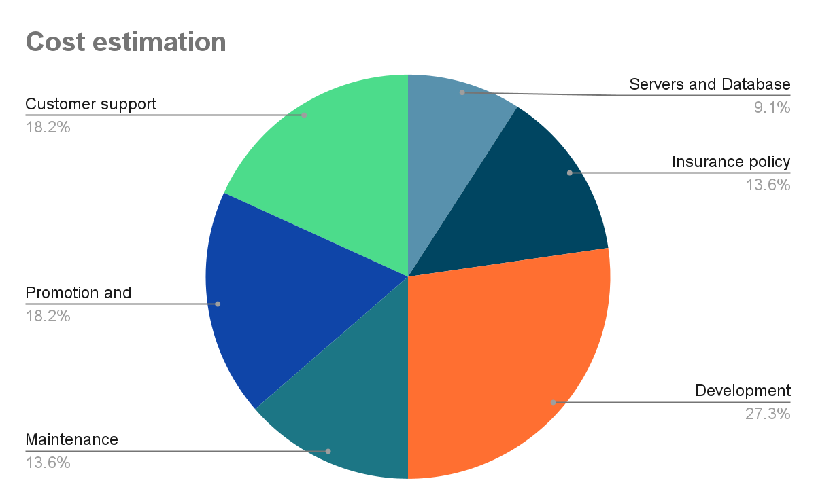

# CHAPTER 9 | Risk and Solution

**Market Risk:**

* Conduct market research and surveys to gauge user interest and preferences.
* Analyze the competition to identify gaps and opportunities in the market.
* Consider offering promotions to attract initial users.
* Monitor user feedback and adjust the program to align with organizational goals.
* Conduct a competitive analysis to identify similar products and their strengths and weaknesses.

**Financial Risk:**

* Conduct a cost-benefit analysis to assess the program's financial impact.
* Does our organization have enough money to support the program?
* How many years will it take for the program to return benefits?
* Develop a financial forecast that includes revenue projections and cost estimates.

**Technology Risk:**

* Can present technology support our program?
* Do we have enough hardware and software?
* Implement a maintenance plan to ensure the longevity of technology assets.
* Will technology become outdated before we start working?
* Stay updated on technology trends and industry developments.
* Consider scalability and future-proofing during the development process.

**People Risk (Stakeholders):**

* Do we have enough programmers?
* Recruit and train additional programmers if necessary.
* Consider outsourcing or partnering with external experts.
* Do the programmers have the skills we need?
* Ensure the team has expertise in relevant programming languages and technologies.
* Build loyalty through excellent customer service and communication.

**Structure/Process Risk:**

* Involve relevant stakeholders in the process design and implementation.
* How many target users will use our program?
* Define clear user personas and conduct market segmentation to estimate target user numbers.
* Consider scalability to accommodate growth in user numbers.
* Analyze the project landscape to identify potential dependencies and competition.
* Mitigate risks related to project overlap or resource constraints.
* Prioritize projects within the organization to ensure alignment with strategic goals.
* Coordinate project timelines and dependencies to minimize conflicts.
* Establish clear communication channels to address potential delays or resource constraints.

**Technology failure**

| **Risk ID** | **Headline** | **Description** | **Priority level** | **Impact** | **Likelihood** | **Mitigation strategy** |
| --- | --- | --- | --- | --- | --- | --- |
| 1 | System down | The risk of system downtime due to technical issues, such as server failures, software bugs, or cyberattacks. | High | High | Unlikely | Implement redundancy in critical system components, conduct regular system maintenance, and establish incident response protocols. |
| 2 | Data Security Breaches | The risk of data breaches or leaks that could compromise user information. | High | High | Moderate | encryption, intrusion detection systems, and employee training on security best practices. Regularly audit and update security protocols to address emerging threats. |

**Human failure**

| **Risk ID** | **Headline** | **Description** | **Priority level** | **Impact** | **Likelihood** | **Mitigation strategy** |
| --- | --- | --- | --- | --- | --- | --- |
| 3 | Employee Errors | The risk of internal staff making mistakes, such as inaccurate data entry or mishandling customer interactions. | Medium | High | Low | Implement quality control measures, establish standardized processes, and provide ongoing training for employees. Create an error reporting mechanism for quick identification and resolution of issues. |
| 4 | Employee Resignation | The risk of key employees leaving the organization, leading to a loss of critical knowledge. | Medium | High | Moderate | Document processes and procedures, cross-train employees to ensure knowledge redundancy, and maintain updated documentation. Develop retention strategies to retain key talent. |

**Process failure**

| **Risk ID** | **Headline** | **Description** | **Priority level** | **Impact** | **Likelihood** | **Mitigation strategy** |
| --- | --- | --- | --- | --- | --- | --- |
| 5 | Compliance and Regulatory Risks | The risk of non-compliance with industry regulations and legal requirements. | High | High | Low | Stay informed about industry regulations, engage legal experts to ensure compliance, and establish a compliance monitoring program. Implement necessary controls to meet regulatory requirements. |
| 6 | Ineffective Quality Control | The risk of poor data quality or inaccurate responses being provided to users, leading to customer dissatisfaction and operational inefficiencies. | Low | Medium | Low | Develop and maintain a quality assurance team responsible for reviewing and validating the accuracy of responses generated by the self-service system. Continuously monitor and improve the quality control procedures to ensure that users receive reliable and accurate information. |

# 

# CHAPTER 10 | User journey

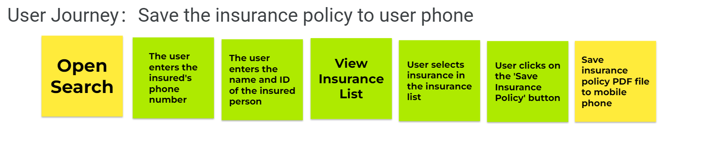

# CHAPTER 11 | URS and SRS

**URS - User requirements specification**

URS01: Users can enter the phone number of the insured person, provided that the phone number must comply with Thai mobile phone number specifications(+66 XXX-XXX -XXXX).

URS02: Users can enter the name of the insured person

URS03: The user can enter the ID number of the insured, provided that the ID number must be standardized for ISO 7064:1983,MOD.

URS04: Users can view the insurance list of the insured, which includes each relevant insurance name, purchase time, and current status of the queried insured.

URS05: Users can open individual insurance in the insured's insurance list.

URS06: Users can save PDF files of opened policies, provided that the user's phone storage space is greater than 512MB. After successful retention, notify the user of " Save successfully'"

**SRS - System requirements specification**

SRS01: The system provides a phone number input box for users.

SRS02: The system does not allow users to enter phone numbers that do not comply with Thai phone number specifications (+66 XXXX-XX-XXXX).

SRS03: The system will provide an input box for users to input the insured person name.

SRS04: The system provides an input box for users to enter the ID number of the insured.

SRS05: The ID number that the system does not allow the user to enter does not conform to the specification for ISO 7064:1983,MOD.

SRS06: If there is no relevant information, a prompt will be returned indicating that the user has no relevant information.

SRS07: The system will display the insured's insurance list which includes each relevant insurance name, purchase time, and current status of the queried insured.

SRS08: The system will display the insurance policy selected by the user.

SRS09: The system provides a button to allow users to maintain a PDF file of the currently opened insurance policy.

SRS10: When using the save function, the system does not allow the remaining storage space to be less than 512MB.

SRS11: After successful saving, the system will prompt 'Save successfully'

# CHAPTER 12 | Use case diagram

**Feature 1 - multi language selection**

**Feature 2 - retrieving and self saving insurance policies**

**Feature 3 - Self appointment renewal service**

# CHAPTER 13 | Use case description

| Use Case ID | UC-01 | | | |
| --- | --- | --- | --- | --- |
| Use Case Name | Multi Language Selection | | | |
| Created By | Haoxuan Yu | | Last Update By | Haoxuan Yu |
| Date Created | 16/09/2023 | | Last Revision Date | 18/09/2023 |
| Actors | User: The customer of insurance and insured person | | | |
| Description | Users can choose from a variety of languages to facilitate their choice of insurance | | | |
| Trigger | When the user wants to use another language, click the language switch button | | | |
| Preconditions | * Users can only open using mobile software * Users first need to download this software * The memory must be at least 512GB * Users need to use this function while connected to the network | | | |
| Use Case Input Specification | | | | |
| Input | type | Constraint | | Example |
| - | - | - | | - |
| Post conditions | The user needs to complete the language modification click | | | |
| Normal Flows | User | | System | |
|  | 1. First the user clicks to open the software | |  | |
|  |  | | 2.Software connection network response complete and open  A2.1:Only 10 languages can be displayed on the language interface at a time  E2.1: No internet, later to try | |
| 3. Select the language page |  | |  | |
|  | 4. The user selects the language to switch  A4.1: When we select a language, we need to confirm whether to confirm or deny the language | |  | |
|  |  | | 5.The system successfully switches the language  A5.1: Network is not good, switchover failed, please try again  E5.1: The network is not good. The switchover failed | |
| Alternative Flow | A2.1:Only 10 languages can be displayed on the language interface at a time  A4.1:When we select a language, we need to confirm whether to confirm or deny the language  A5.1: Network is not good, switchover failed, please try again | | | |
| Exception Flow | E2.1: There is no internet, please do the transaction later  E5.1: The network is not good. The switchover failed | | | |
| Assumption | The user successfully switched to English | | | |

| Use Case ID | UC-02 | | | |
| --- | --- | --- | --- | --- |
| Use Case Name | Self-saving insurance policies | | | |
| Created By | Haoxuan Yu | | Last Update By | Haoxuan Yu |
| Date Created | 16/09/2023 | | Last Revision Date | 18/09/2023 |
| Actors | User: The customer of insurance and insured person | | | |
| Description | The user can log in to search for the information of the insured by entering the relevant information | | | |
| Trigger | When users searching insurance that click button | | | |
| Preconditions | * Users can only open using mobile software * Users first need to download this software * Users need to use this function while connected to the network * provided that the phone number must comply with Thai mobile phone number specifications (+66 XXX-XXX -XXXX).   Must meet ISO7064:1983, MOD specification | | | |
| Use Case Input Specification | | | | |
| Input | type | Constraint | | Example |
| Ding Zhen | Text | Names can't be numbers | | Life insurance: 18/09/2023  Under insurance |
| Cai Xukun | Text | Names can't be numbers | | accident insurance: 18/09/2023  Not within the insured time |
| Post conditions | There's a name for this in the system. | | | |
| Normal Flows | User | | System | |
|  | 1.Click on the icon to open the software | |  | |
|  |  | | 2.After the system responds, pop up the login system  E2.1: network anomaly | |
|  |  | | 3. Waiting for Entering phone number | |
|  | 4. User enters phone number  A4.1: Limit Thai numbers to more than 10 digits, no more can be entered  E4.1: Cannot exceed 10 bit limit in interface  E4.2: There is no phone number to try again | |  | |
|  |  | | 5. Waiting for Entering Enter name of the insured person | |
|  | 6. User enters name of the insured person  A6.1: Names can't be entered by numbers, and numbers can't be typed  E6.1: Cannot enter numbers to display on the page  E6.2: The name is incorrect. The related information cannot be queried | |  | |
|  |  | | 7. Waiting for Entering Enter ID number of the insured | |
|  | 8.User enters ID number of the insured  A8.1: The ID can only be a number. Other characters cannot be entered  E8.1: Characters other than numbers are not allowed  E8.2: The ID is incorrect. The related information cannot be queried | |  | |
|  |  | | 9. After the system is successfully loaded, the page is displayed  E9.1: network anomaly | |
|  | 10. Click the query button and enter the name of the person you want to query  A10.1: Users input keywords, such as their initial letter, and relevant personnel with this name in relevant order will pop up | |  | |
|  |  | | 11. The system will automatically search for content related to this name, such as insurance content, dates, etc | |
| Alternative Flow | A4.1: Limit Thai numbers to more than 10 digits, no more can be entered  A6.1: Names can't be entered by numbers, and numbers can't be typed  A8.1: The ID can only be a number. Other characters cannot be entered  A10.1: Users input keywords, such as their initial letter, and relevant personnel with this name in relevant order will pop up | | | |
| Exception Flow | E2.1: network anomaly  E4.1: Cannot exceed 10 bit limit in interface  E4.2: There is no phone number to try again  E6.1: Cannot enter numbers to display on the page  E6.2 The name is incorrect. The related information cannot be queried  E8.1: Characters other than numbers are not allowed  E8.2: The ID is incorrect. The related information cannot be queried  E9.1: network anomaly | | | |
| Assumption | The user successfully queried the information about the insured | | | |

| Use Case ID | UC-03 | | | |
| --- | --- | --- | --- | --- |
| Use Case Name | Self Appointment Renewal Service | | | |
| Created By | Haoxuan Yu | | Last Update By | Haoxuan Yu |
| Date Created | 16/09/2023 | | Last Revision Date | 18/09/2023 |
| Actors | User: The customer of insurance | | | |
| Description | Users can log in to the system and choose the insurance they want to renew (only those that can be reserved are allowed). | | | |
| Trigger | When the user needs to make an appointment to renew the insurance, and then click the renewal button | | | |
| Preconditions | * Users can only open using mobile software * Users first need to download this software * The memory must be at least 512GB * Users need to use this function while connected to the network * You can only click to make an appointment for renewal | | | |
| Use Case Input Specification | | | | |
| Input | type | Constraint | | Example |
| - | - | - | | - |
| Post conditions | The user enters the renewal page is normal, there are no other problems such as network fluctuations | | | |
| Normal Flows | User | | System | |
|  |  | | 1. Have gone through the steps to enter the page   E1.1 Refreshing the page to enter again | |
|  | 2. Click to schedule renewal | |  | |
|  |  | | 3. Please select the type of renewal you would like to schedule  E3.1: Network exception please click again | |
| 4. Some types of insurance |  | |  | |
|  | 5. Choose which one you want to renew  A5.1: Only select the one that can be renewed by appointment, otherwise it cannot be renewed  E5.1: Insurance that cannot be reserved cannot be selected for reservation | |  | |
|  |  | | 6.Waiting, the appointment renewal succeeded  E6.1 The network is abnormal. Please wait again or try again | |
| Alternative Flow | A5.1: Only select the one that can be renewed by appointment, otherwise it cannot be renewed | | | |
| Exception Flow | E1.1 Refreshing the page to enter again  E3.1: Network exception please click again  E5.1: Insurance that cannot be reserved cannot be selected for reservation  E6.1 The network is abnormal. Please wait again or try again | | | |
| Assumption | The user successfully made an insurance appointment | | | |

# CHAPTER 14 | Activity Diagram

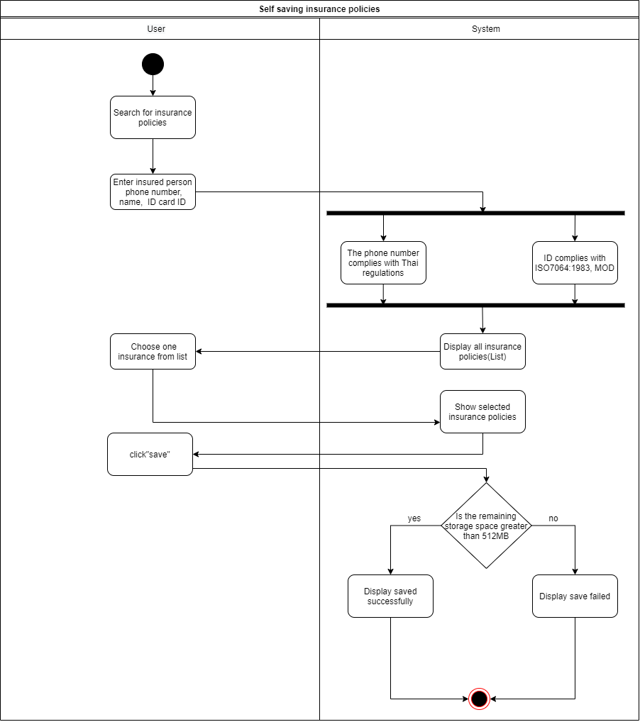

# CHAPTER 15 | Non-functional requirement with fit criterias

* Users must be able to complete the policy retrieval process within 60 seconds on their first attempt.
* The application should be designed to accommodate a scalable user base. It should support a minimum of 10,000 concurrent users during peak usage without significant performance degradation.
* The application shall aim for 99.9% uptime, with planned maintenance windows communicated in advance to users.
* The application shall maintain consistent response times across different geographic regions, ensuring that users receive similar performance regardless of their location.
* User account information, including login credentials and personal details, shall be stored securely using strong encryption and hashing techniques.
* The application must comply with all relevant industry-specific and regional regulatory standards, including insurance and data privacy regulations.

# CHAPTER 16 | UI

<https://shorturl.at/svLOU>

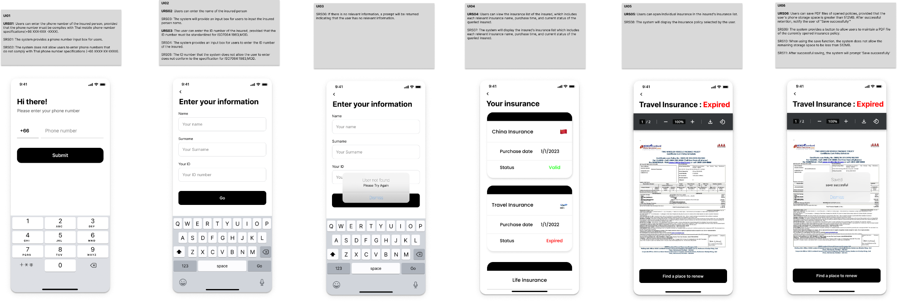

# CHAPTER 17 | Traceability Table/Matrix

**URS-SRS**

|  | URS-01 | URS-02 | URS-03 | URS-04 | URS-05 | URS-06 |
| --- | --- | --- | --- | --- | --- | --- |
| SRS-01 |  |  |  |  |  |  |
| SRS-02 |  |  |  |  |  |  |
| SRS-03 |  |  |  |  |  |  |
| SRS-04 |  |  |  |  |  |  |
| SRS-05 |  |  |  |  |  |  |
| SRS-06 |  |  |  |  |  |  |
| SRS-07 |  |  |  |  |  |  |
| SRS-08 |  |  |  |  |  |  |
| SRS-09 |  |  |  |  |  |  |
| SRS-10 |  |  |  |  |  |  |
| SRS-11 |  |  |  |  |  |  |

**URS-UI**

|  | URS-01 | URS-02 | URS-03 | URS-04 | URS-05 | URS-06 |
| --- | --- | --- | --- | --- | --- | --- |
| UI-01 |  |  |  |  |  |  |
| UI-02 |  |  |  |  |  |  |
| UI-03 |  |  |  |  |  |  |
| UI-04 |  |  |  |  |  |  |
| UI-05 |  |  |  |  |  |  |
| UI-06 |  |  |  |  |  |  |

SRS-UI

|  | SRS-01 | SRS-02 | SRS-03 | SRS-04 | SRS-05 | SRS-06 | SRS-07 | SRS-08 | SRS-09 | SRS-10 | SRS-11 |
| --- | --- | --- | --- | --- | --- | --- | --- | --- | --- | --- | --- |
| UI-01 |  |  |  |  |  |  |  |  |  |  |  |
| UI-02 |  |  |  |  |  |  |  |  |  |  |  |
| UI-03 |  |  |  |  |  |  |  |  |  |  |  |
| UI-04 |  |  |  |  |  |  |  |  |  |  |  |
| UI-05 |  |  |  |  |  |  |  |  |  |  |  |
| UI-06 |  |  |  |  |  |  |  |  |  |  |  |

URS-UC

UC-AD